The four squares on the behavioural style matrix represent four distinct behavioural types.
For each of us, our behavioural style can be viewed as our personal "comfort zone", or the style we adopt most naturally when not under stress.
We are going to apply labels to these four behavioural styles - however I stress they are only labels. What is important are the characteristics which are described, not the definition of the word itself.

What the Different Axis Labels Mean

RESPONSIVENES (Y-axis)
People can respond in two ways: a control manner or an emotive way

Control Response
Applied to people who rarely show their emotions. Typical behaviours include:
- Immobile face
- Fixed eye contact
- Closed, formal body posture
- Monotone voice
- Task orientation
- Small gestures
- Static body

Emote responsive:
Applied to people who openly show their feelings and emotions. Typical behaviours include:
- Facial mobility and animation.
- Short duration of eye contact
- Open body position *Informality
- Inflexion in voice
- Large gestures
- Mobile body movements

ASSERTIVENESS (X axis)
People can assert themselves in two ways – in a “telling” way or “asking” manner

"Tell" assertiveness
A way of influencing that is more obvious to others: eg. "That was a stupid thing to do." "Tell" behaviours include:
- Loud voice
- Clipped speech
- Intense eye contact
- More gestures
- Faster actions
- Stating opinions
- Thinking of self first

"Ask" assertiveness
A way of influencing that is not perceived as so overt as "telling": eg. "I don't think that that was a good idea because blah, blah, blah. What do you think?"
"Ask" behaviours include:
- Quiet voice
- Measured speech
- Less intense eye contact
- Fewer gestures
- Slower body movements
- Listening
- Thinking of others first

Behaviour Styles – looking at the four quadrants rather than the axes:
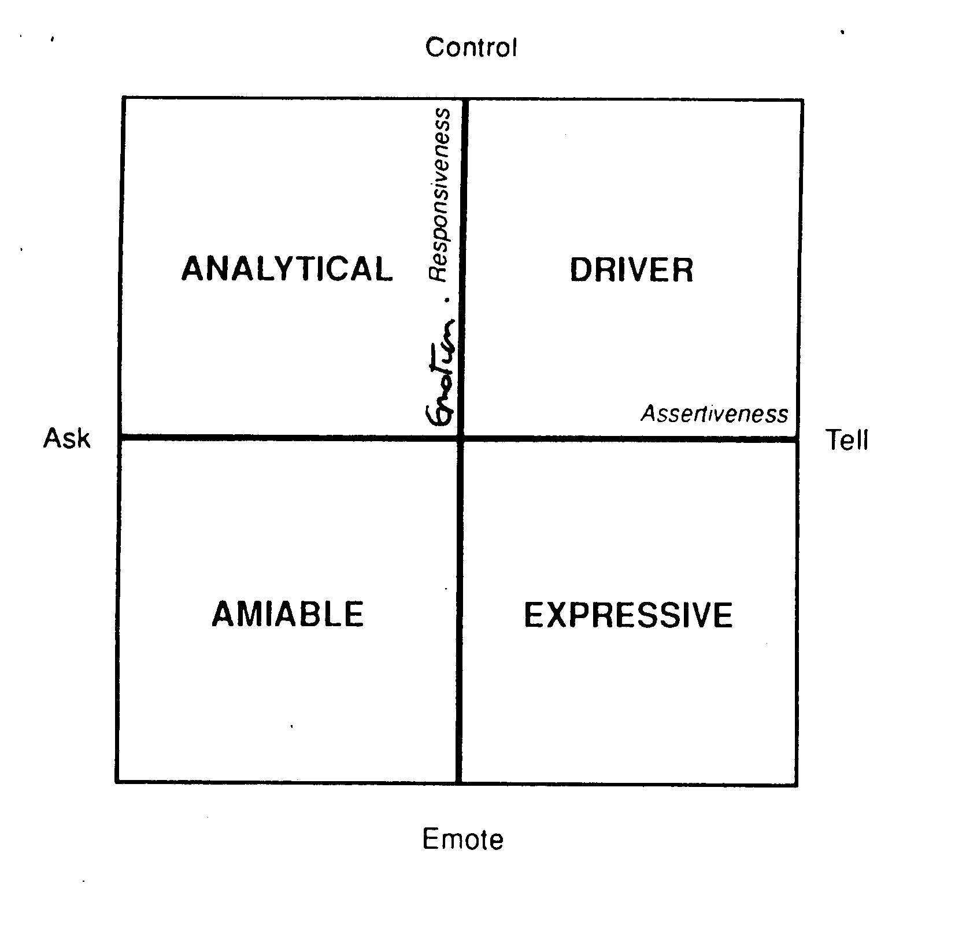

A Bit More About these Four Different Behavioural Styles:

Driver, or controlling style: (Sir Alan Sugar)
Drivers are business-like and formal in appearance. Their main priority is the task in hand, and the results achieved. Their pace is fast and decisive. They prefer an atmosphere that encourages control of people and processes, and achieve acceptance through their productivity and competitiveness.
Drivers like to be in charge, seek productivity, and dislike loss of control. They want you in turn to get to the point, because they are irritated by inefficiency and indecision. They measure their personal worth by the results they achieve, and their track record.
Under pressure, Drivers will assert themselves strongly, and dictate the way things are going to be i.e. autocratic.
To win over and work with a Driver, you need therefore to support their goals and objectives, and demonstrate what your ideas will do, by when, and at what cost i.e. results.

- Pace: Fast, decisive
- Voice: Clipped, monotone
- Posture: Formal, forward
- Gestures: Small, precise
- Eye Contact: Intense, direct
- Face: Fixed, immobile

Drivers are brisk and business-like, and like to get things done.
- Like to be in charge, and get results.
- Hate indecision and inefficiency.
- Base decisions on relevant facts, objectivity.
- Under pressure become autocratic and dictatorial.

With Drivers, do:
- Get on with it!
- Be factual and succinct
- Talk about results
- Use time efficiently

Don't:
- Waste their time
- Be vague and rambling
- Try to get too personal
- Try to control them
- Be disorganised

Expressive, or enthusing style: (Russell Grant, Russell Brand)
Expressives appear to be more flamboyant. Their tendency is to interact within relationships and they dislike any loss of prestige. Their pace is fast and spontaneous. They try to create an atmosphere that encourages flexibility and achieve acceptance through sociability and creating a stimulating environment.

Expressives want to be admired, seek recognition, and dislike being ignored. They want you in turn to be stimulating because they are irritated by routine and boredom. They measure their personal worth by the amount of recognition and acknowledgement (or complaints) they receive.

Under pressure, an Expressive will go on the offensive or be sarcastic.

To win over and work with an Expressive we need therefore to support their dreams and ideas, and show how you can help enhance their standing with others.

- Pace: Fast, spontaneous
- Voice: Loud, fast, modulated
- Posture: Relaxed, open
- Gestures: Large, frequent
- Eye Contact: Intense, but infrequent
- Face: Very mobile, animated.

Expressives are sociable, flamboyant.
- Seek recognition, and dislike being ignored.
- Irritated by routine, and lack of stimulation.
- Base decisions on intuition.
- Under pressure, will go on the offensive and attack.

With Expressives, do:
- Be prepared to socialise
- Be enthusiastic and energetic
- Offer your opinions
- Support their ideas
- Be flexible, spontaneous

Don't:
- Be impatient or controlling
- Bore them
- Give them too much detail or facts
- Irritate them!

Amiable, or supportive style:
Amiables appear to be casual but conforming, Their preference is to maintain relationships and avoid confrontation. Their pace is slow and easy. They prefer an atmosphere that encourages close relationships, and achieve acceptance through conformity and loyalty.

Amiables want to be appreciated. seek attention, and try to avoid confrontation. They want you in turn to be pleasant because they are irritated by insensitivity and impatience. They measure their personal worth by their degree of compatibility with others and the depth of their relationships.

Under pressure, an Amiable will submit or acquiesce.

To win over and work with Amiables, we need therefore to support their feelings, and show how our ideas will support their personal circumstances.

- Pace: Slow, easy
- Voice: Soft, modulated,
- Posture: Relaxed, informal
- Gestures: Large, but few
- Eye Contact: Warm, friendly
- Face: Open, animated

Amiables prefer to maintain relationships, and avoid confrontation.
- Want to be appreciated, and in turn are supportive, and think of others first.
- Irritated by insensitivity and impatience.
- Base decisions on feelings, trust, people.
- Under pressure, will acquiesce, or submit.

With Amiables, do:
- Be friendly and informal
- Show interest in them personally
- Take your time
- Give them time to make decisions
- Listen and be supportive of their feelings.

Don't:
- Rush them
- Be factual
- Be distant, and stand-offish
- Give them cause to mistrust you.

Analytical, or processing style: (John Major)
Analyticals appear somewhat formal and conservative. Their main priority is the job in hand, and the process to achieve it. Their pace is measured and systematic. They prefer an atmosphere that encourages careful preparation and achieve acceptance through being correct, logical and thorough.

Analyticals want recognition as being correct, seek accuracy, and dislike embarrassment. They want you in turn to be precise in your dealings with them, because they are irritated by unpredictability and surprises. They measure their personal worth by their degree of precision, accuracy and activity.

Under pressure, an Analytical will withdraw into their own world, and avoid contact with the causes of stress.

To win over and work with an Analytical, we need therefore to support their thinking, and show how our ideas will support their personal credibility.

- Pace: Measured, systematic
- Voice: Quiet, monotone
- Posture: Formal, stiff
- Gestures: Small, few
- Eye Contact: Reflective, steady
- Face: Fixed, unexpressive

Analyticals are concerned with the job in hand, and the process to achieve it.
- They like time to prepare, and are logical and thorough
- They dislike unpredictability, and being rushed.
- Base decisions on lots of facts, credibility.
- Under pressure will withdraw, and avoid cause of stress.

With Analyticals, do:
- Get down to business
- Listen carefully
- Be formal and quiet
- Give them time to think and to put their point of view.
- Be specific and logical

Don't:
- Rush them
- Interrupt them
- Be flippant and casual
- Be disorganised or late
- Lack credibility

A Summary
 | Driver | Analytical | Amiable | Expressive
Facial Expression | fixed | fixed | varied | varied
Eye Contact | intense  long duration | reflective | empathetic | intense  short duration  scattered
Posture | formal | formal | informal | informal
Body Movement | limited | limited | more mobility | more mobility
Gestures: Size | small | small | larger | larger
Gestures: Frequency | high | low | low | high
Voice: Tone | monotone | monotone | inflexion | inflexion
Voice: Speed | fast, clipped | slow, measured | slow, measured | fast
Voice: Volume/Force | louder | softer | softer | louder
Decision Making | quick  limited facts | slower  lots of facts | slower  lots of opinions | fast  intuition

Characteristic | Axis
Facial expression | |
Body movement | |
Posture | |
Eye contact | +
No of gestures | ―
Size of gestures | |
voice - volume | ―
Voice - speed | ―
Voice - tone | |
Content and decision making process within 4 quadrants | +

How will Others React in a Conflict Situation?
